#
# 20181120
# Needs mount ha-drbd01p-metro.tcsbank.ru:/drbd0 on server vm-sassys01p.
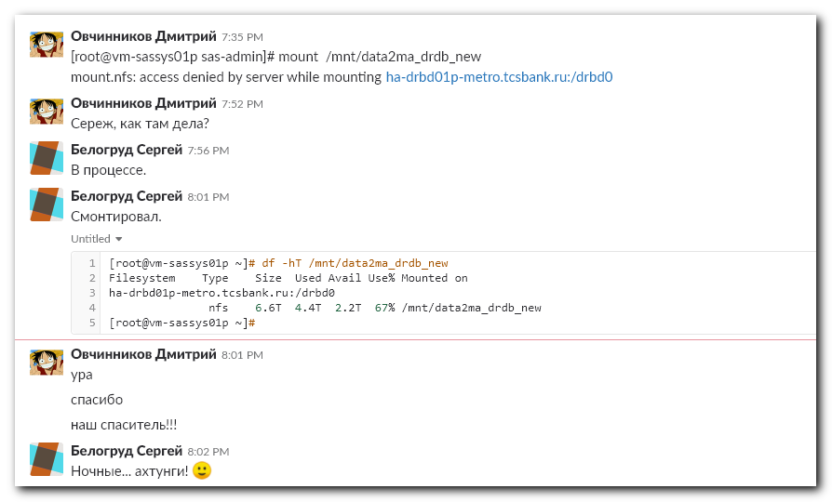
[root@vm-sassys01p ~]# mount -v /mnt/data2ma_drdb_new
mount.nfs: trying text-based options 'bg,vers=3,tcp,timeo=600,rsize=65536,wsize=65536,hard,addr=10.217.65.157'
mount.nfs: prog 100003, trying vers=3, prot=6
mount.nfs: trying 10.217.65.157 prog 100003 vers 3 prot TCP port 2049
mount.nfs: prog 100005, trying vers=3, prot=6
mount.nfs: trying 10.217.65.157 prog 100005 vers 3 prot TCP port 20048
mount.nfs: mount(2): Permission denied
mount.nfs: access denied by server while mounting ha-drbd01p-metro.tcsbank.ru:/drbd0
[root@vm-sassys01p ~]#

[root@vm-sassys01p ~]# grep -ie "/mnt/data2ma_drdb_new" /etc/fstab
ha-drbd01p-metro.tcsbank.ru:/drbd0 /mnt/data2ma_drdb_new nfs rw,bg,vers=3,tcp,timeo=600,rsize=65536,wsize=65536,hard 0 0
[root@vm-sassys01p ~]#

#
# It’s a special resource of DRBD cluster.
# More info could be found here: https://wiki.tcsbank.ru/display/TECHSUPPORT/DRBD+2018
# But not too much.
# This nfs-resource can belong one of two servers.
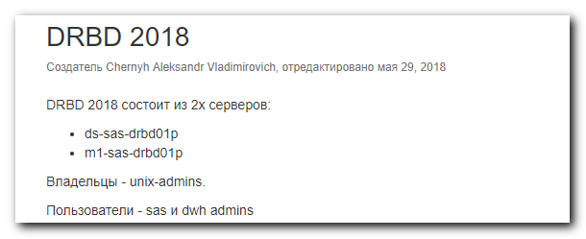

#
# It’s need to write access line into /etc/exports file on each of these servers.

[root@vm-sassys01p ~]# host ha-drbd01p-metro.tcsbank.ru
ha-drbd01p-metro.tcsbank.ru has address 10.217.65.157
[root@vm-sassys01p ~]#

#
# I’ve found ip on the first server.
[root@ds-sas-drbd01p ~]# ip -f inet addr | grep inet
inet 127.0.0.1/8 scope host lo
inet 10.216.31.11/24 brd 10.216.31.255 scope global team0.1631
inet 10.216.31.13/24 brd 10.216.31.255 scope global secondary team0.1631
inet 10.217.49.6/24 brd 10.217.49.255 scope global team0.1749
inet 10.217.65.19/24 brd 10.217.65.255 scope global team0.1765
inet 10.217.65.157/24 brd 10.217.65.255 scope global secondary team0.1765
[root@ds-sas-drbd01p ~]#

[root@m1-sas-drbd01p ~]# ip -f inet addr | grep inet
inet 127.0.0.1/8 scope host lo
inet 10.216.31.10/24 brd 10.216.31.255 scope global team0.1631
inet 10.217.49.7/24 brd 10.217.49.255 scope global team0.1749
inet 10.217.65.20/24 brd 10.217.65.255 scope global team0.1765
[root@m1-sas-drbd01p ~]#

#
# I’ve found ip-interface in same VLAN as target ip (10.217.65.157). And then use it to grant access for it.
[root@vm-sassys01p ~]# ip -f inet addr | grep inet
inet 127.0.0.1/8 scope host lo
inet 10.216.24.3/24 brd 10.216.24.255 scope global eth0
inet 10.217.65.58/24 brd 10.217.65.255 scope global eth1
[root@vm-sassys01p ~]#

# I’ve did it on both servers - ds-... and m1-...
[root@ds-sas-drbd01p ~]# vim /etc/exports
...
#vm-sassys01p
/drbd0 10.217.65.58(rw,async,no_root_squash,no_subtree_check)
...

[root@m1-sas-drbd01p ~]# vim /etc/exports
...
#vm-sassys01p
/drbd0 10.217.65.58(rw,async,no_root_squash,no_subtree_check)
...

#
# At this moment need to run on both servers
[root@ds-sas-drbd01p ~]# exportfs -r

[root@m1-sas-drbd01p ~]# exportfs -r

# Before “exportfs -r” - no new access.
[root@ds-sas-drbd01p ~]# exportfs | grep -B 1 -ie "10.217.65.58"
/drbd1/drbd_sas_data
10.217.65.58
[root@ds-sas-drbd01p ~]#

# After “exportfs -r” - new line become available.
[root@ds-sas-drbd01p ~]# exportfs | grep -B 1 -ie "10.217.65.58"
/drbd0 10.217.65.56
/drbd0 10.217.65.58
--
/drbd1/drbd_sas_data
10.217.65.58
[root@ds-sas-drbd01p ~]#

#
# After that - I could mount successfully.
[root@vm-sassys01p ~]# mount -v /mnt/data2ma_drdb_new
mount.nfs: trying text-based options 'bg,vers=3,tcp,timeo=600,rsize=65536,wsize=65536,hard,addr=10.217.65.157'
mount.nfs: prog 100003, trying vers=3, prot=6
mount.nfs: trying 10.217.65.157 prog 100003 vers 3 prot TCP port 2049
mount.nfs: prog 100005, trying vers=3, prot=6
mount.nfs: trying 10.217.65.157 prog 100005 vers 3 prot TCP port 20048
ha-drbd01p-metro.tcsbank.ru:/drbd0 on /mnt/data2ma_drdb_new type nfs (rw,bg,vers=3,tcp,timeo=600,rsize=65536,wsize=65536,hard)
[root@vm-sassys01p ~]# df -hT /mnt/data2ma_drdb_new
Filesystem Type Size Used Avail Use% Mounted on
ha-drbd01p-metro.tcsbank.ru:/drbd0
nfs 6.6T 4.4T 2.2T 67% /mnt/data2ma_drdb_new
[root@vm-sassys01p ~]#

#
# That’s important thing.
# Some of resources are export with “ro” rights. If try to mount it with standard “rw” permissions - it will be unable.
# Servers ...sasetl… have ip-addresses in same subnet as interface ha-drbd01p-metro.tcsbank.ru [10.217.65.157].
# This means - in /etc/exportfs file need to use appropriate ip-addresses of servers in same subnet.

[root@ds-sasetl01x ~]# ip -f inet addr | grep inet
inet 127.0.0.1/8 scope host lo
inet 10.216.6.11/24 brd 10.216.6.255 scope global eth9
inet 10.216.7.11/24 brd 10.216.7.255 scope global eth8
inet 10.216.29.14/24 brd 10.216.29.255 scope global bond0
inet 10.217.65.55/24 brd 10.217.65.255 scope global bond1
inet 10.217.32.115/24 brd 10.217.32.255 scope global bond2
[root@ds-sasetl01x ~]#

[root@m1-sasetl01t ~]# ip -f inet addr | grep inet
inet 127.0.0.1/8 scope host lo
inet 10.216.1.67/24 brd 10.216.1.255 scope global eth8
inet 10.216.0.67/24 brd 10.216.0.255 scope global eth9
inet 10.216.27.4/24 brd 10.216.27.255 scope global bond0
inet 10.217.32.23/24 brd 10.217.32.255 scope global bond1
inet 10.217.65.56/24 brd 10.217.65.255 scope global bond2
[root@m1-sasetl01t ~]#

